INDEX

Sl No | Name of the program | Date | Page No | Remarks
1 | Create your class time table using table tag. |  | 2
2 | Design a web Page for your college containing description of courses, department, faculties, library etc. Using list tags, href tags and anchor tags. |  | 5
3 | Create a resume using html . Use text,link and lists. |  | 9
4 | Create a webpage of a supermarket using internal CSS. |  | 12
5 | Using inline CSS to format your resume that you have created. |  | 16
6 | Use external CSS to format your timetable created. |  | 19
7 | Use all CSS (inline,internal,external)to format college webpage |  | 22
8 | Create college website for mobile devices. |  | 26

Program 1
Create class time table using table tag

Aim
Create a html page to display class time table

Program

<!DOCTYPE html>

<html>

<head>

<title>Time Table</title>

</head>

<body>

<table align="center" border="2">
<h2 align=”center”>This is the timetable for the semester 2 BCA Students</h2>
<tr>
<th></th>
<th>HOUR 1</th>
<th>HOUR 2</th>
<th>HOUR 3</th>
<th>HOUR 4</th>
<th>HOUR 5</th>
</tr>

<tr>
<td>DAY1</td>
<td>DS</td>
<td>OS</td>
<td>English</td>
<td>WEB1</td>
<td>WEB2</td>
</tr>

<tr>
<td>DAY2</td>
<td>H/M</td>
<td>DS</td>
<td>OS</td>
<td>MATHS</td>
<td>MATHS</td>

</tr>

<tr>
<td>DAY3</td>
<td>DS</td>
<td>ENGLISH</td>
<td>H/M</td>
<td>WEB</td>
<td>OS</td>

</tr>

<tr>
<td>DAY4</td>
<td>OS</td>
<td>MATHS</td>
<td>IC</td>
<td>ENGLISH</td>
<td>H/M</td>

</tr>

<tr>
<td>DAY5</td>
<td>DS</td>
<td>MATHS</td>
<td>ENGLISH</td>
<td>DS</td>
<td>DS</td>

</tr>
</table>
</body>

</html>

Output
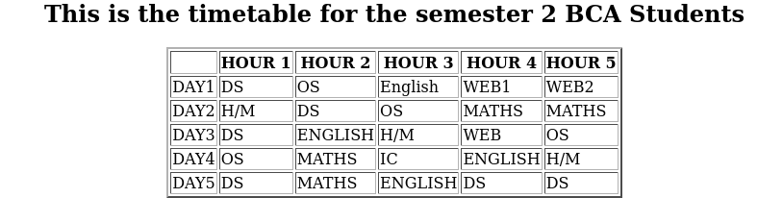

Program 2
Design a web Page for your college containing description of courses, department, faculties, library ect. Using list tags, href tags and anchor tags.

Aim
Design a web Page for your college containing description of courses, department, faculties, library etc. Using list tags, href tags and anchor tags.

Program

<!DOCTYPE html>
<html>

<head>
<title>College Website</title>

</head>

<body>
<h2>St George college Aruvithura</h2>
<dl>
<dt><h3 align="center">About</h3></dt>
<dd>St. George's College Aruvithura is a college under Mahatma Gandhi University, Kottayam. It is located in Aruvithura, Erattupetta, Kottayam District in Kerala, India. It was reaccredited with 'A++' Grade by NAAC for seven years in the fourth cycle.

St. George’s College Aruvithura, is a minority educational institution founded by St. George Forane Church, Aruvithura in 1965. Pioneered under the patronage of His Excellency Mar Sebastian Vayalil, the first Bishop of Pala, and cherished by a host of visionaries and philanthropists like Very Rev. Fr. Thomas Araythinal and Mr T. A. Thomman (Former Minister), the college, right from its inception, embarked on an odyssey towards academic pre-eminence. Very Rev. Fr. Thomas Manakkat, the founding manager and a great visionary, was truly instrumental in laying the foundations for a great beginning and Very Rev. Fr. Jacob Thazhathel, who followed him, was equally adept and insightful in his ideals, guiding the college during the early stages of its growth. For more than two decades, His Excellency Mar Joseph Pallickaparampil, the Bishop of Pala, had been the patron of the college. His Excellency Mar Joseph Kallarangattu is the present patron of this seat of learning.

Currently, the college offers 17 undergraduate courses, and 5 postgraduate courses and the Department of Chemistry and Physics are recognized Research Centers under MG University.</dd>
</dl>

<h3 align="center"><img src="images.png" width="400" alt="St George Colleege Aruvithura" id="image"></h3>
<h3 align="center">Departments</h3>
<ol>

<li>Deparment of botony and zoology</li>
<li>Department of chemistry</li>
<li>Department of physics</li>
<li>Deparment of commerce</li>
<li>Political Science</li>
<li>English</li>
<li>Food Scienceand Quality Control (Self Financing) </li>
<li>BCom [Co-operation (SF)]</li>
<li>BCA(sf)</li>
<li>BCA(aided)</li>
</ol>
<h3 align="center">BCA Faculties</h3>

<table align="center" border="2">

<tr>
<th>Name</th>
<th>subject</th>
</tr>
<tr>
<td>Dr. Jestin Joy</td>
<td>web appplication</td>
</tr>
<tr>
<td>Dr. Sowmya </td>
<td>os</td>
</tr>
<tr>
<td>Dr. Gemini</td>
<td>data structure</td>
</tr>
<td>Tince Mathew</td>
<td>mathematics</td>
</tr>

</table><br>
<h3 align="center">Courses/Program</h3>
<ul>
<li>UG</li>
<ol>
<li>B.Sc (Honours) Mathematics </li>
<li>B.Sc (Honours) Physics </li>
<li>B.Sc (Honours) Chemistry </li>
<li>B.Sc (Honours) Botany </li>
<li>B.A (Honours) Economics </li>
<li>B.A (Honours) Political Science </li>
<li>B A (Honours) English with Specialization in Media Studies & Film Studies </li>
<li>B.Com (Honours) with Specialization in Finance & Taxation View</li>
<li>BCA (Honours) with Specialization in Data Science & Full Stack Development</li>
</ol>
<li>PG</li>
<ol>
<li>M.Sc. Physics </li>
<li>M. Sc. Chemistry </li>
<li>Integrated MA English</li>
</ol>
</ul>
<h4 align ="center"><a href ="sgcaruvithura.in">College Website</a></h4>

</body>

</html>
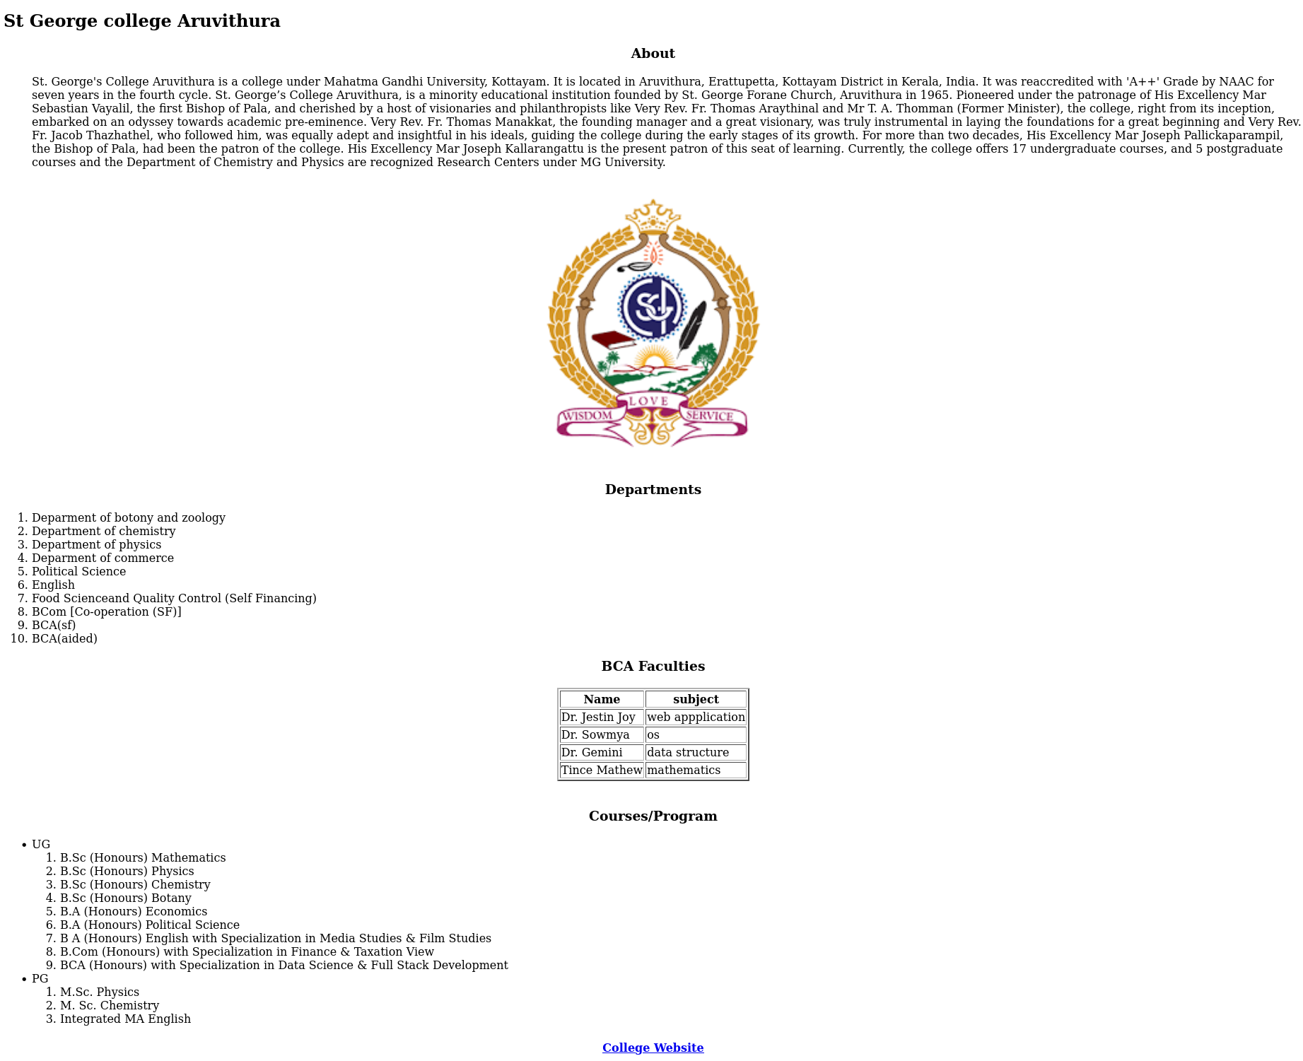
Output:

Program 3
Create a resume using html . Use text,link and lists .

Aim
Create a resume using html . Use text,link and lists.

Program

<!DOCTYPE html>
<html>

<head>

<title>Resume</title>
</head>Program

<body>

<h1>Angelo Francis</h1>
<h3><p>+91 9497167172| angelofrancis2007@gmail.com| Idukki,Kerala</p></h3><br><br>
<h2>Education</h2>
<ul>
<li>BCA : St George College Aruvithura,2025-26</li><br>
<li>Higher secondary : St George HSS Kattappana,2023-25</li><br>
<li> High school : St George HSS Kattappana,2022-23</li><br>
</ul>

<h2>Skills</h2>
<p>HTML<br>JavaScript<br>CSS<br>c</p>
<h2>Languages known</h2>
<ul>
<li>English(Fluent)</li><br>
<li>Hindi(Fluent)</li><br>
<li>Malayalam(Fluent)</li><br>
</ul>
<h2>Academic Projects</h2>
<ul>
<Li>E-commerce website data analysis(python)</li><br><br>
<li>College placement Tracker(Wipro)</li>
</ul><br>
<h2>Certifications</h2>
<ul>
<li>Introduction to Back-End development</li><br>
<li>Introduction to software Engineering</li><br>
<li>Accelerate your job search using AI</li><br>
</ul>
<h2>Experience</h2>
<ul>
<li>Inter-Data Analyst|ABC solutions|3 months|2026</li><br>
<li>Volunteer-Event cordinator</li>

</ul>
<br><br>
<h4><a href ="linkedin.in">LinkedIn Account</a></h4>
<h4><a href ="coursera.in">Cousera </a></h4>
<h4><a href ="github.in">GitHub</a></h4>
</body>
</html>

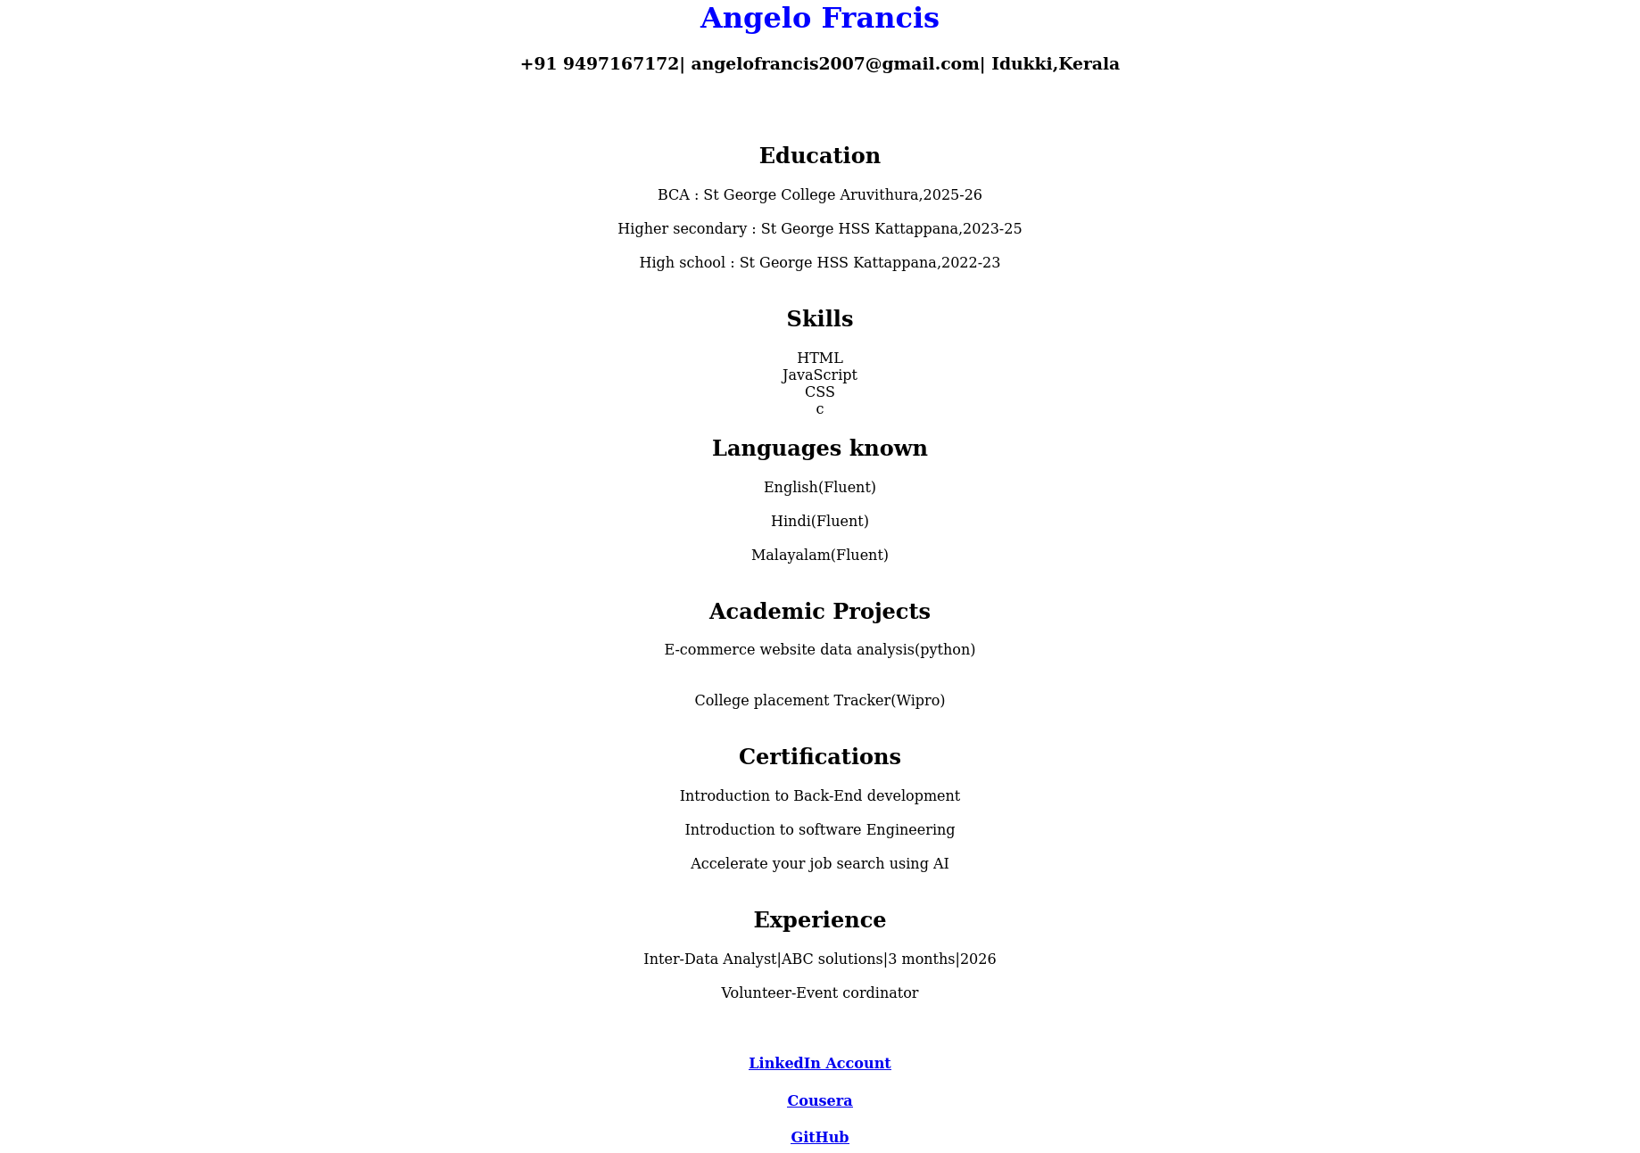
Output

Program 4
Create a webpage of a supermarket using internal css.

Aim
Create a webpage of a supermarket using internal CSS.

Program
<!DOCTYPE html>
<html>
<head>
<title>Super Market</title>
<style>
h2{
color:blue;
}
ul{
color:red;
text-align:center;
margin:auto;
padding: 0;

}
h1{
color:green;
}
</style>
</head>
<body>
<div class="container">
<div class="row">
<div class="col-12">
<div class="text-center">
<h1 align="center"><img src="logo.png" class="img-fluid"></h2>
</div>
</div>
</div>
<h1 align="center">SuperMarket Menu</h1>
<div class="row">
<div class="col-12 col-lg-6">
<h2 align="center">Fruits</h2>
<ul><li>Mango</li><li>orange</li><li>Apple</li><li>strawberry</li></ul>
<h2 align="center">vegetable</h2>
<ul><li>Carrot</li><li>Potato</li><li>Beetroot</li></ul>
</div>
<div class="col-12 col-lg-6">
<h2 align="center">Powders</h2>
<ul><li>Turmeric</li><li>Chilly</li><li>Fish</li><li>Meat</li></ul>
<h2 align="center">Drinks</h2>
<ul><li>cola</li><li>Fanta<?li><li>Pepsi</li><li>7up</li>
</div>
</div>
</div>
</div>
</body>
</html>

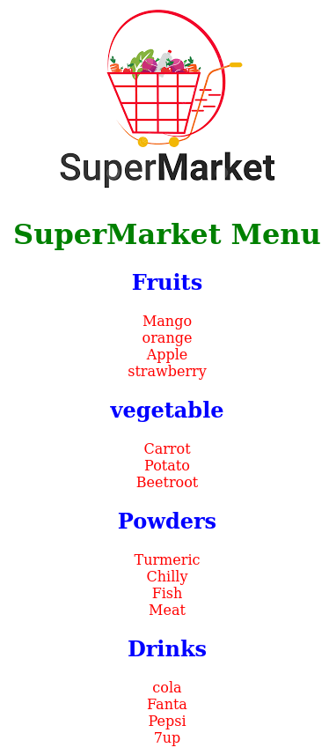
Output

Program 5
Using inline CSS to format your resume that you have created.

Aim
Using inline CSS to format your resume that you have created.
Program

<html>

<head>
<style>
h1{
text-align:center;
color:blue;
}
h2{
text-align:center;
}
ul{
text-align:center;
margin:auto;
padding:0;
}
</style>

<title>Resume</title>
</head>

<body>

<h1>Angelo Francis</h1>
<h3><p align="center">+91 9497167172| angelofrancis2007@gmail.com| Idukki,Kerala</p></h3><br><br>
<h2 align="center">Education</h2>
<ul>
<li>BCA : St George College Aruvithura,2025-26</li><br>
<li>Higher secondary : St George HSS Kattappana,2023-25</li><br>
<li> High school : St George HSS Kattappana,2022-23</li><br>
</ul>

<h2>Skills</h2>
<p align="center">HTML<br>JavaScript<br>CSS<br>c</p>
<h2 align="center">Languages known</h2>
<ul>
<li>English(Fluent)</li><br>
<li>Hindi(Fluent)</li><br>
<li>Malayalam(Fluent)</li><br>
</ul>
<h2>Academic Projects</h2>
<ul>
<Li>E-commerce website data analysis(python)</li><br><br>
<li>College placement Tracker(Wipro)</li>
</ul><br>
<h2>Certifications</h2>
<ul>
<li>Introduction to Back-End development</li><br>
<li>Introduction to software Engineering</li><br>
<li>Accelerate your job search using AI</li><br>
</ul>
<h2>Experience</h2>
<ul>
<li>Inter-Data Analyst|ABC solutions|3 months|2026</li><br>
<li>Volunteer-Event cordinator</li>

</ul>
<br><br>
<h4 align ="center"><a href ="linkedin.in">LinkedIn Account</a></h4>
<h4 align ="center"><a href ="coursera.in">Cousera </a></h4>
<h4 align ="center"><a href ="github.in">GitHub</a></h4>
</body>
</html>

Output

Program 6
Use external CSS to format your timetable created.

Aim
Use external CSS to format your timetable created.
Program
<!DOCTYPE html>

<html>

<head>

<title>Time Table</title>
<link rel="stylesheet" href="styles.css">
</head>

<body>

<table align="center" border="2">
<h2 >This is the timetable for the semester 2 BCA Students</h2>
<tr>
<th></th>
<th>HOUR 1</th>
<th>HOUR 2</th>
<th>HOUR 3</th>
<th>HOUR 4</th>
<th>HOUR 5</th>
</tr>

<tr>
<td>DAY1</td>
<td>DS</td>
<td>OS</td>
<td>English</td>
<td>WEB1</td>
<td>WEB2</td>
</tr>

<tr>
<td>DAY2</td>
<td>H/M</td>
<td>DS</td>
<td>OS</td>
<td>MATHS</td>
<td>MATHS</td>

</tr>

<tr>
<td>DAY3</td>
<td>DS</td>
<td>ENGLISH</td>
<td>H/M</td>
<td>WEB</td>
<td>OS</td>

</tr>

<tr>
<td>DAY4</td>
<td>OS</td>
<td>MATHS</td>
<td>IC</td>
<td>ENGLISH</td>
<td>H/M</td>

</tr>

<tr>
<td>DAY5</td>
<td>DS</td>
<td>MATHS</td>
<td>ENGLISH</td>
<td>DS</td>
<td>DS</td>

</tr>
</table>
</body>

</html>
External
table{
text-align:center;
background-color:yellow;
}
h2{
text-align:center;
color:blue;
}
Output

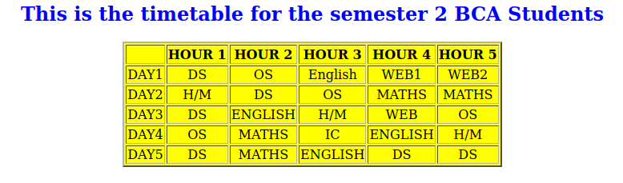

Program 7
Use all CSS (inline,internal,external)to format college webpage

Aim
Use all CSS (inline,internal,external)to format college webpage
Program
<!DOCTYPE html>
<html>

<head>
<link rel="stylesheet" href="styles1.css">
<title>College Website</title>
<style>
dd{
color:green;
font-size: 20px;
}
</style>
</head>

<body>
<h2>St George college Aruvithura</h2>
<dl>
<dt><h3 align="center">About</h3></dt>
<dd>St. George's College Aruvithura is a college under Mahatma Gandhi University, Kottayam. It is located in Aruvithura, Erattupetta, Kottayam District in Kerala, India. It was reaccredited with 'A++' Grade by NAAC for seven years in the fourth cycle.

St. George’s College Aruvithura, is a minority educational institution founded by St. George Forane Church, Aruvithura in 1965. Pioneered under the patronage of His Excellency Mar Sebastian Vayalil, the first Bishop of Pala, and cherished by a host of visionaries and philanthropists like Very Rev. Fr. Thomas Araythinal and Mr T. A. Thomman (Former Minister), the college, right from its inception, embarked on an odyssey towards academic pre-eminence. Very Rev. Fr. Thomas Manakkat, the founding manager and a great visionary, was truly instrumental in laying the foundations for a great beginning and Very Rev. Fr. Jacob Thazhathel, who followed him, was equally adept and insightful in his ideals, guiding the college during the early stages of its growth. For more than two decades, His Excellency Mar Joseph Pallickaparampil, the Bishop of Pala, had been the patron of the college. His Excellency Mar Joseph Kallarangattu is the present patron of this seat of learning.

Currently, the college offers 17 undergraduate courses, and 5 postgraduate courses and the Department of Chemistry and Physics are recognized Research Centers under MG University.</dd>
</dl>

<h3 align="center"><img src="images.png" width="400" alt="St George Colleege Aruvithura" id="image"></h3>
<h3 align="center">Departments</h3>
<ol>

<li>Deparment of botony and zoology</li>
<li>Department of chemistry</li>
<li>Department of physics</li>
<li>Deparment of commerce</li>
<li>Political Science</li>
<li>English</li>
<li>Food Scienceand Quality Control (Self Financing) </li>
<li>BCom [Co-operation (SF)]</li>
<li>BCA(sf)</li>
<li>BCA(aided)</li>
</ol>
<h3 align="center">BCA Faculties</h3>

<table align="center" border="2">

<tr>
<th>Name</th>
<th>subject</th>
</tr>
<tr>
<td>Dr. Jestin Joy</td>
<td>web appplication</td>
</tr>
<tr>
<td>Dr. Sowmya </td>
<td>os</td>
</tr>
<tr>
<td>Dr. Gemini</td>
<td>data structure</td>
</tr>
<td>Tince Mathew</td>
<td>mathematics</td>
</tr>

</table><br>
<h3 align="center">Courses/Program</h3>
<ul>
<li>UG</li>
<ol>
<li>B.Sc (Honours) Mathematics </li>
<li>B.Sc (Honours) Physics </li>
<li>B.Sc (Honours) Chemistry </li>
<li>B.Sc (Honours) Botany </li>
<li>B.A (Honours) Economics </li>
<li>B.A (Honours) Political Science </li>
<li>B A (Honours) English with Specialization in Media Studies & Film Studies </li>
<li>B.Com (Honours) with Specialization in Finance & Taxation View</li>
<li>BCA (Honours) with Specialization in Data Science & Full Stack Development</li>
</ol>
<li>PG</li>
<ol>
<li>M.Sc. Physics </li>
<li>M. Sc. Chemistry </li>
<li>Integrated MA English</li>
</ol>
</ul>
<h4 align ="center"><a href ="sgcaruvithura.in">College Website</a></h4>

</body>

</html>

Output

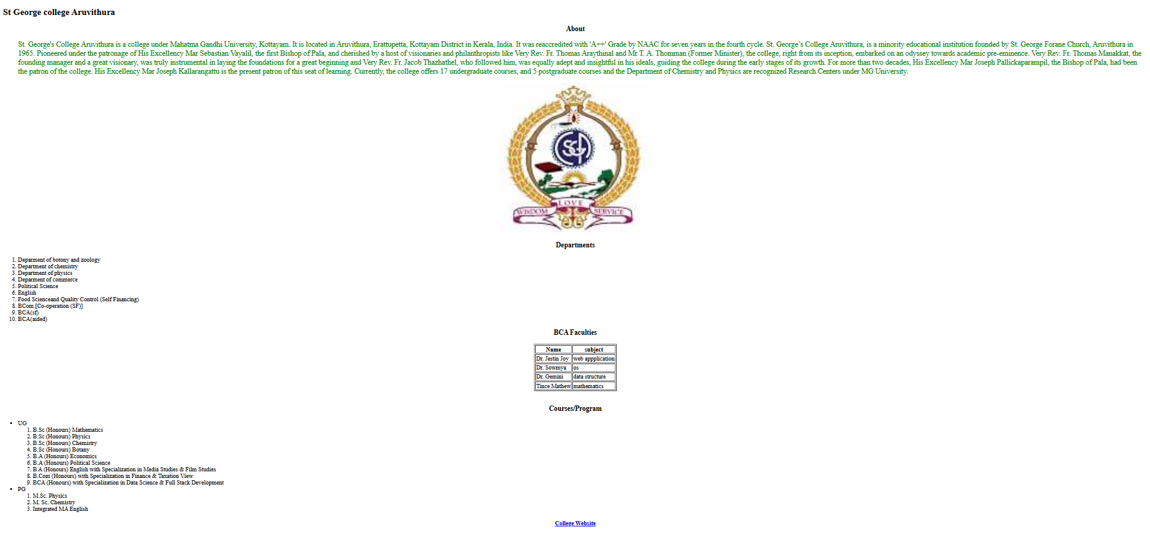

Program 8
Create college website for mobile devices.

Aim
Create college website for mobile devices.
Program
<!DOCTYPE html>
<html>

<head>
<link rel="stylesheet" href="styles1.css">
<title>College Website</title>
<style>
dd{
color:green;
font-size: 20px;
}
</style>
<meta name="viewport" content="width="device-width, initial-scale=1.0">
</head>

<body>
<h2>St George college Aruvithura</h2>
<dl>
<dt><h3 align="center">About</h3></dt>
<dd>St. George's College Aruvithura is a college under Mahatma Gandhi University, Kottayam. It is located in Aruvithura, Erattupetta, Kottayam District in Kerala, India. It was reaccredited with 'A++' Grade by NAAC for seven years in the fourth cycle.

St. George’s College Aruvithura, is a minority educational institution founded by St. George Forane Church, Aruvithura in 1965. Pioneered under the patronage of His Excellency Mar Sebastian Vayalil, the first Bishop of Pala, and cherished by a host of visionaries and philanthropists like Very Rev. Fr. Thomas Araythinal and Mr T. A. Thomman (Former Minister), the college, right from its inception, embarked on an odyssey towards academic pre-eminence. Very Rev. Fr. Thomas Manakkat, the founding manager and a great visionary, was truly instrumental in laying the foundations for a great beginning and Very Rev. Fr. Jacob Thazhathel, who followed him, was equally adept and insightful in his ideals, guiding the college during the early stages of its growth. For more than two decades, His Excellency Mar Joseph Pallickaparampil, the Bishop of Pala, had been the patron of the college. His Excellency Mar Joseph Kallarangattu is the present patron of this seat of learning.

Currently, the college offers 17 undergraduate courses, and 5 postgraduate courses and the Department of Chemistry and Physics are recognized Research Centers under MG University.</dd>
</dl>

<h3 align="center"><img src="images.png" width="400" alt="St George Colleege Aruvithura" id="image"></h3>
<h3 align="center">Departments</h3>
<ol>

<li>Deparment of botony and zoology</li>
<li>Department of chemistry</li>
<li>Department of physics</li>
<li>Deparment of commerce</li>
<li>Political Science</li>
<li>English</li>
<li>Food Scienceand Quality Control (Self Financing) </li>
<li>BCom [Co-operation (SF)]</li>
<li>BCA(sf)</li>
<li>BCA(aided)</li>
</ol>
<h3 align="center">BCA Faculties</h3>

<table align="center" border="2">

<tr>
<th>Name</th>
<th>subject</th>
</tr>
<tr>
<td>Dr. Jestin Joy</td>
<td>web appplication</td>
</tr>
<tr>
<td>Dr. Sowmya </td>
<td>os</td>
</tr>
<tr>
<td>Dr. Gemini</td>
<td>data structure</td>
</tr>
<td>Tince Mathew</td>
<td>mathematics</td>
</tr>

</table><br>
<h3 align="center">Courses/Program</h3>
<ul>
<li>UG</li>
<ol>
<li>B.Sc (Honours) Mathematics </li>
<li>B.Sc (Honours) Physics </li>
<li>B.Sc (Honours) Chemistry </li>
<li>B.Sc (Honours) Botany </li>
<li>B.A (Honours) Economics </li>
<li>B.A (Honours) Political Science </li>
<li>B A (Honours) English with Specialization in Media Studies & Film Studies </li>
<li>B.Com (Honours) with Specialization in Finance & Taxation View</li>
<li>BCA (Honours) with Specialization in Data Science & Full Stack Development</li>
</ol>
<li>PG</li>
<ol>
<li>M.Sc. Physics </li>
<li>M. Sc. Chemistry </li>
<li>Integrated MA English</li>
</ol>
</ul>
<h4 align ="center"><a href ="sgcaruvithura.in">College Website</a></h4>

</body>

</html>

Output


Program 9
Calculator using JavaScript.

Aim
Calculator using JavaScript.
Program

<!DOCTYPE html>
<html>
<script>
function checkvalue()
{
let num1=document.getElementById("num1").value;
let op=document.getElementById("op").value;
let num2=document.getElementById("num2").value;
let ans;
if(op=='+')
{
ans=Number(num1)+Number(num2);
}
if(op=='-')
{
ans=Number(num1)-Number(num2);
}
if(op=='*')
{
ans=Number(num1)*Number(num2);
}
if(op=='/')
{
ans=Number(num1)/Number(num2);
}
document.getElementById("ans").innerHTML("ans");
}
</script>
</head>
<body>
FistNumber:<input type="text" id="num1" >
Operation:<input type="text" id="op">
SecondNumber:<input type="text" id="num2">
<input type="button" value="submit">
</body>
</html>

Output
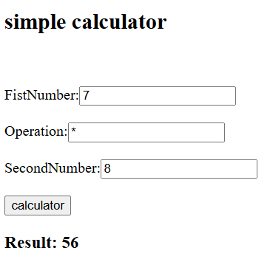

Program 10
Create a validation page.

Aim
Create a validation page.
Program
<!DOCTYPE html>
<html>
<head>
<script>
function validate()
{
let username=document.getElementById("username").value;
let password=document.getElementById("pass").value;
if(username.trim()==="")
{
alert("Username required");
return false;
}
if(!(password.length>6&&password.length<12))
{

alert("password must be between 6 and 12");
return false;
}
alert("login successful");
}

</script>

</head>
<body>
Username: <input type="text" id="username"><br><br>
password: <input type="text" id="pass"><br><br>
<input type="button" value="submit" onclick="validate()">

</body>
</html>

Output

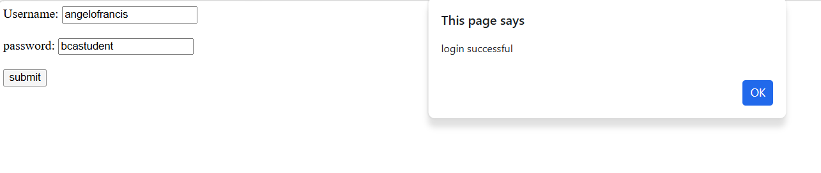

Program 11
Validation using Regular expression.

Aim
Validation using regular expression.
Program
<!DOCTYPE html>
<html>
<head>
<script>
function validate()
{
let email=document.getElementById("email").value;
let password=document.getElementById("pass").value;
let emailpattern=/\w+\.\w+/;
if(!emailpattern.test(email))
{
alert("please enter valid mail");
return false;
}
if(password.length<6)
{
alert("Enter a 6 digit password");
return false;
}
alert("login successful");
return true;
}
</script>

</head>
<body>
Email: <input type="text" id="email"><br><br>
password: <input type="text" id="pass"><br><br>
<input type="button" value="submit" onclick="validate()">

</body>
</html>

Output

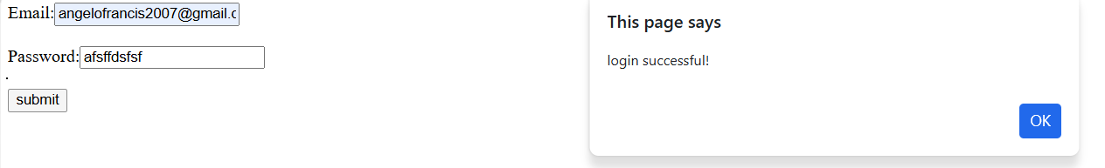

Program 12
Retreive data and display using Ajax.

Aim
Retreive data and display using Ajax.
Program
<!DOCTYPE html>
<html><head>
<meta http-equiv="content-type" content="text/html; charset=windows-1252">
<title>AJAX JSON Example</title>
</head>

<body>

<h2>Student List</h2>

<button onclick="loadStudents()">Load Students</button>

<ul id="result"></ul>

<script>

function loadStudents()
{
let xhr = new XMLHttpRequest();

xhr.open("GET", "students.json", true);

xhr.onload = function()
{
let students = JSON.parse(xhr.responseText);

let output = "";

for (let i in students)
{
output += "<li>" + students[i].name +
" - " + students[i].course +
" - " + students[i].mark +
"</li>";
}

document.getElementById("result").innerHTML = output;
};

xhr.send();
}

</script>

</body></html>

Output

Program 12
Create a webpage using frameset.

Aim
Create a webpage using frameset.
Program
Header_frame
<!DOCTYPE html>
<html>
<head>
<style>
h1{
text-align:center;
color:blue;
}
body{
background-color:yellow;
}
</style>
</head>
<body>
<h1>St George college Aruvithura</h1>
</body>
</html>

Left_frame
<!DOCTYPE html>
<html>
<head>
</head>
<body>
<h2>Navigations</h2>
<ul>
<li><a href="frameset.html" target="right">BCA department</a></li>
<li><a href="library.html" target="right">Library</a></li>
<li><a href=’sgctv.html”target=”right”>SGC TV</a></li>

</ul>
</body>
</html>

Index.html
<!DOCTYPE html>
<html>
<head>
<title>Frame</title>
</head>
<frameset rows="15%,75%,10%">
<frame src="header_frame.html">
<frameset cols="40%,60%">
<frame src="left_frame.html">
<frame name="right" src="">
</frameset>

</frameset>
</html>

library.html
<!DOCTYPE html>
<html>
<head>
</head>
<body>
<p>St George college aruvithura,has a rich history,started functioning in 1965.Over the years, it has undergone significant upgrades and expansion to become first-grade library.In 1978,the post of a first-grade librarian and a IV-grade librarian were sanctioned, indicating the growing importance of the library as a vital academic resource.</p>
<h3 align="center"><img src="images.png" width="400" alt="St George Colleege Aruvithura" id="image"></h3>
</body>
</html>

sgctv.html
<!DOCTYPE html>
<html>
<head>
</head>
<body>
<p>St George college has their own SGC TV</p>
</body>
</html>

frameset.html
<!DOCTYPE html>
<html>
<head>
</head>
<body>
<h4>Deparments of computer application</h4>
<table border="1">
<tr>
<td><b>Faculties</b><br><br></td>
</tr>
<tr>
<td>Dr. justin joy</td>
</tr>
<tr>
<td>Dr. Sowmya George</td>
</tr>
<tr>
<td>Dr. Linu Thomas</td>
</tr>
<tr>
<td>Dr. Gemini George</td>
</tr>
</body>
</html>

Output

